Cochlear Implant Nerve Model

Technical Description

Version 1.0

Authors: Ben Williges and Tim Jürgens, University of Oldenburg, November 2013

The cochlear implant nerve model (CINM) is a population model of the auditory nerve spiking in response to electrical stimulation. It was developed by Hamacher (2004) and re-implemented in MATLAB by Fredelake and Hohmann (2012). This technical description is the detailed reference about the model structure and some details about the implementation in version 1.0. This technical description contains direct citations from the Fredelake and Hohmann (2012)-paper (with permission). These citations are printed in italic. The sections about the electrical compound action potentials (ECAPs) are direct translations of chapter 7 of the dissertation of Hamacher (2004).

Introduction

The general model structure
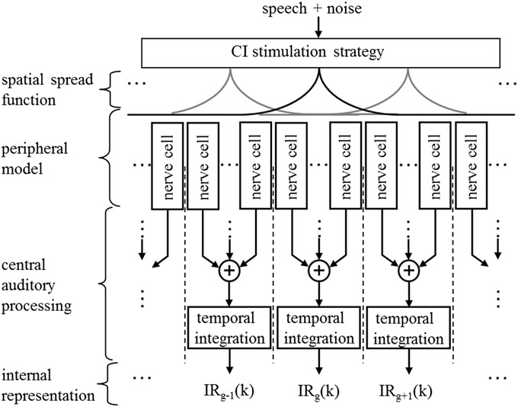
Figure 1 (from Fredelake et al., 2012): Model sketch of the electrically stimulated auditory system. The model includes a simulation of a CI signal processing strategy, spatial spread functions, a population model of auditory nerve cells, and the central auditory system with spatial and temporal integration (based on Hamacher, 2004).
Fig. 1 shows the general structure of the model (Hamacher, 2004). An acoustic signal is processed with an n-of-m signal processing strategy (Vandali et al., 2000) of a simulated CI. The parameter settings for CI simulation, i.e., the map, were fixed with realistic values for the number of active electrodes, pulse rate, pulse width, Threshold Current Level (TCL), Most Comfortable Level (MCL) and loudness growth function, i.e., the mapping of the acoustic signal amplitude to electric stimulus amplitude. The CI simulation outputs were interleaved electrical current pulses S_{i} that served as inputs to the model. The index i = 1, 2, 3 denotes the pulses in the temporal order of their appearance. Each pulse is described by its current amplitude I (A), its phase duration T_{ph} (s), and the time instance of the onset of the cathodic phase t_{p} (s). Furthermore, the electrode that generates the pulse is defined by its position in the cochlea x_{el} (mm). In short, each S_{i} is described by S_{i} =(I, T_{ph}, x_{el}, t_{p}). First, for each S_{i} and for each auditory nerve cell, the model decides if and when an action potential is released. Second, all action potentials are further processed in the central auditory processing stage by spatial and temporal integration. The model is restricted to biphasic and interleaved pulses. Furthermore, only the cathodic phase of the biphasic pulses (i.e., I> 0) is modeled, while the anodic phase is neglected. It is important to note that the map, as well as the positions of the electrodes, were kept constant in the model simulations in order to reduce the number of parameters. Furthermore, parameter values for each of the auditory nerve cells were randomly distributed with a defined mean and standard deviation resulting in different thresholds and refractory behavior, for example. The parameters were derived from electrophysiological measurements from the literature and are described in the Supplementary material.

CI stimulation strategy

ACE
There are two different implementations of the ACE n-of-m-strategy (Vandali et al., 2000) currently available, one custom implementation (Matlab m-Files) and one closed implementation that was provided by Fraunhofer IDMT (Matlab p-Files). These strategies provide slightly different output, however, the closed implementation was tested to be closely matching the stimulation output of a real CI speech processor from brand Cochlear. The function ACE_signal_processing.m outputs the custom ACE strategy and the function ACE_FilterBank_VecInput.m outputs the ACE strategy by Fraunhofer IDMT.

Auditory nerve Model

Spatial spread function
Electrical stimuli applied to CI electrodes produce an electric field that spreads within the cochlea, stimulating auditory nerve cells closest to the active electrode with the highest currents and distant nerve cells with lower currents (see Fig. 2). To model the instantaneous spatial field spread, it was assumed for simplicity that the cochlea was unwound and that all nerve cells were equally distributed with fixed positions x_{n} between 0 mm and 35 mm, whereby x_{n} = 0 mm refers to the position of the most apical and x_{n}= 35 mm to the most basal nerve cell. With x_{el} and a spread constant λ (mm), the spatial spread function for monopolar stimulation is modeled with a double-sided one-dimensional exponentially decreasing function
v(x_{n},x_{el}) = |v₀(exp($-\frac{|x_{n}-x_{el}|}{λ}$))|
with v₀ as the maximum. For details of the implementation, see calculate_AVF.m. The positions of the 22 electrodes are distributed with equal spacing between x_{el}= 8.125 and 23.875 mm with interspaces of 0.75 mm, simulating a Cochlear electrode array (Busby et al., 1994). For details of the implementation and to change the locations, see set_global_constants.m. When an active electrode at x_{el} generates an electric pulse with I, the input current $\tilde{I}$, stimulating a nerve cell at x_{n}, is derived by multiplying I with v(x_{n},x_{el}), i.e., I = v(x_{n}, x_{el}). In the following, the tilde denotes local effective input values for the auditory nerve cells that are independent of the spatial conditions.
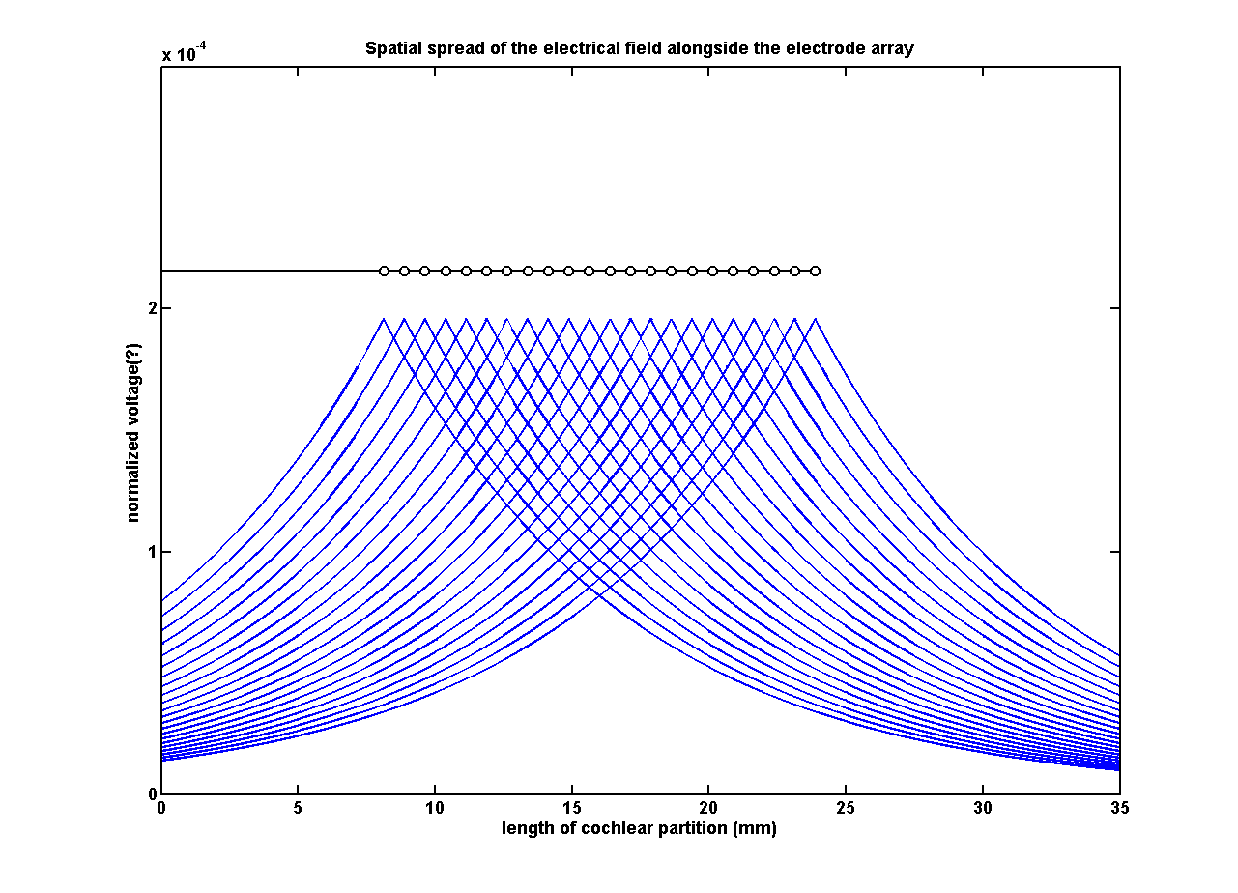
Figure 2: Spatial Spread of the electrical field alongside the electrode array.This figure can be created by clicking the button „Spatial Spread“ in the CINM-GUI

Auditory nerve cell

Figure 3 (from Fredelake et al., 2012): Model of an auditory nerve cell (adopted from Hamacher, 2004, with slight modifications)

Cell membrane
The cell membrane is a deterministic leaky integrate-and-fire model (Gerstner and Kistler, 2002) and consists of a resistance R and capacitance C in parallel (Figure 4). The first step determines whether the depolarization potential U_{D} (V) exceeds the threshold potential U_{th} (V) for a given $\tilde{I}$and T_{ph} at all. For this purpose, the depolarization potential at the end of the cathodic phase
$$U_{D}\left(t=T_{ph}\right)=\check{I}R(1-\exp\left(-\frac{T_{ph}}{τ_{m} }\right))$$
with τ_{m} =RC (s) as the membrane time constant, is compared with the threshold potential: U_{D}(T_{ph} )$≥$ U_{th}. An action potential is generated if this condition is met. Next, the firing time of an action potential t_{f} (s) is calculated under the assumption that the action potential is generated when the depolarization potential is equal to the threshold potential, i.e., U_{D} (t= t_{f})= U_{th}. Equation (2) is solved for t_{f} with
$$t_{f}= τ_{chr}\log_{2}(\frac{\tilde{I}}{\tilde{I}-{\tilde{I}}_{rheo}})$$
Equation (3) includes the chronaxie $τ_{chr}=τ_{m}ln⁡(2)(s)$ and the rheobase ${\tilde{I}}_{rheo}$ = U_{th}=R (A).${\tilde{I}}_{rheo}$ is the minimal electric current amplitude of a rectangular stimulus with infinite phase duration that is required to produce an action potential (Colombo and Parkins, 1987). $τ_{chr}$is defined as the phase duration of a stimulus with the double stimulus amplitude of ${\tilde{I}}_{rheo}$, which is needed to produce an action potential (Reilly, 1992). For details of the implementation see generateChronaxieRheobase.m.
The firing time t_{AP} (s) of the action potential following the electric pulse at time t_{p} is then calculated with t_{AP} =t_{p} + t_{f}. If several pulses S_{i} are applied, a single modeled auditory nerve cell can produce a spike train SP(t) as a sum of delta pulses with the index j at the times t_{APj} :
$$SP\left(t\right)= \sum_{j}{δ(t-t_{APj})}$$
Figure 4 (from Fredelake et al., 2012): Model of the cell membrane. It consists of a resistance and capacitance in parallel.

Membrane noise
Equation (3) holds only for deterministic cell membrane models, i.e., models that generate an action potential if and only if the depolarization potential exceeds the threshold potential. However, due to the stochastic behavior of the ion channels within the membrane, which causes fluctuations in the depolarization potential, action potentials could also be generated by sub-threshold stimuli if the depolarization potential is raised by the additive membrane noise. Conversely, the membrane noise could lower a deterministic suprathreshold depolarization potential below threshold resulting in no action potential. Therefore, the cell membrane model is extended with a zero-mean Gaussian noise source. The noise is low-pass filtered with a cutoff-frequency of 200 Hz and a slope of 3 dB/oct. See membraneNoise.m for details of the implementation. The resulting signal shows only slow temporal fluctuations, which are negligible during the time span Tph of a single pulse. Therefore, only one noise sample UN from this random process is extracted for each pulse at tp and added to UD(Tph), resulting in UND(Tph)=UD(Tph)+ UN. According to Bruce et al. (1999b), the relative spread of the noise $\hat{{RS}_{0}}=\frac{σ_{N}}{U_{th}}$is extended to the phase-dependent relative spread $\hat{{RS}_{0}^{*}}= \hat{{RS}_{0}}(1+αT_{ph}+βT_{ph}^{2})$ with $α=729 s^{-1}$ and $β=-65,833 s^{-2}$as constants. Thus, the standard deviation of the noise $σ_{N}^{*}$ is given by
${σ_{N}^{*}= \hat{{RS}_{0}^{*}}U }_{th}$.
With additive noise, the probability P_{AP} of generating an action potential to S_{i} is given by
$$P_{AP}\left(S_{i}\right)= \frac{1}{2}+\frac{1}{2}\operatorname{erf}\left(\frac{U_{d}\left(T_{ph}\right)-U_{th}}{\sqrt{2}σ_{N}^{*}}\right),$$
which reflects the real input / output behavior of nerve cells as an integrated Gaussian function. t_{f} in equation (3) is extended to
$t_{f}= τ_{chr}\log_{2}(\frac{\tilde{I}}{\tilde{I}-\left(1-\frac{U_{N}}{U_{th}}\right){\tilde{I}}_{rheo}})$.
For implementation details of the last few steps see auditoryNerve.m.

Refractory Behaviour
A refractory period follows the generation of an action potential that is modeled by a threshold potential increase, multiplying its nominal value U_{th} with an exponentially decreasing function$r(Δt_{LAP})$. This exponentially decreasing function was adjusted to experimentally derived probe thresholds following a suprathreshold conditioner (Dynes, 1996) and is given by
$$r\left(Δt_{LAP}\right)= \left\{\begin{aligned}∞, Δt_{LAP}<T_{ARP} \\ \frac{1}{(1-\exp\left(\frac{-Δt_{LAP}-T_{ARP}}{qτ_{RRP}}\right))(1-p\exp\left(\frac{-Δt_{LAP}-T_{ARP}}{τ_{RRP}}\right))}\end{aligned}\right.,Δt_{LAP}≥T_{ARP}$$
with the constants p =0.68 and q =0.1.$Δt_{LAP}$ denotes the difference between t_{p} and the last action potential of this auditory nerve cell. T_{ARP} is the absolute refractory period and s_{RRP} the time constant of the relative refractory period.
Figure 5: Comparison of observed (circles) and modeled (lines) spike probabilities as a function of the stimulus intensity with different pulse rates. This figure can be reproduced by clicking the button "Spike Probability" in the CINM-GUI. Note that no latency was used to reproduce this data

Latency and jitter
The latency is defined as the time between t_{p} and the occurrence of an action potential in the central part of a nerve cell. Hence, the latency is caused by the generation of an action potential and its propagation from the place of excitation, which is in the peripheral part, to the central part of the nerve cell. The former component is caused by the discharge process of the membrane capacitance between t_{p} and t_{AP}, i.e., when the threshold current is exceeded and an action potential is generated. The second component is modeled with a functional approach based on a fit to the data from Miller et al. (1999a). Miller et al. (1999a) measured decreasing values for latency and jitter with increasing stimulus level in 62 auditory nerve cells from cats. To establish a relation between spiking probability PAP and latency and jitter, they expressed the stimulus level in terms of the corresponding spiking probability PAP.
The incorporation of latency and jitter into the model is done as follows: The data of Miller et al. (1999a) are described by a linear fit to the data as a function of P_{AP}, yielding m_{d}(P_{AP}) and σ_{d}(P_{AP}). P_{AP} is calculated for stimuli that generate an action potential. Afterward, m_{d} and σ_{d} are calculated and used to generate a latency value d with the random process d = N(m_{d}, σd). See calculate_latency_dj.m for details. Finally, this random value is used to delay the time instance of an action potential with $t_{AP}^{*}=t_{AP}+d.$ (See AuditoryNerve.m for implementation details.) Thus, each action potential in the spike train from equation (4) is delayed, resulting in
$${SP}^{*}\left(t\right)= \sum_{j}{δ(t-t_{APj}^{*})}$$

Central auditory processing
The aim of the model of central auditory processing is to retrieve an “internal representation” from the action potential pattern, i.e., a quantitative perceptual measure that is related to the electrical stimuli. The most important aspect of this model stage is spatial and temporal integration of neural activity to account for, e.g., tonotopic organization of neural activity (Yost, 2012) and temporal masking (Chatterjee, 1999). The first stage of the central auditory processing model performs a spatial integration of the action potentials, i.e., the action potentials from neighboring nerve cells are grouped.

Before entering the first stage, the spike trains are resampled to a sampling rate of fs = 5000 Hz. Thus, the spike train can be written as
$${SP}^{*}\left(k\right)= \sum_{j}{δ(k-k_{APj}^{*})}$$
With $k_{APj}^{*}=round(f_{s}t_{APj}^{*}$. Afterward, non-overlapping groups of neighboring auditory nerve cells are formed each associated with the electrode closest to the group. The spatial limits of each group are defined as the arithmetic midpoints between the position of the associated electrode and the positions of its left and right neighbors. Beyond the most basal and apical electrodes this grouping procedure is applied with a constant group width of 0.75 mm, in order to simplify the use of an optimal detector. The activity ${SPG}_{g}(k)$ of a group g is given by a summation of the spike trains of the neurons n within g:
$${SPG}_{g}\left(k\right)= \sum_{n∈g}{\sum_{j}{δ(k-k_{APj}^{*})}}.$$
Note, that the grouping procedure is tailored to the Cochlear electrode array with 22 electrodes and a distance of 0.75 mm between adjacent electrodes (Busby et al., 1994). For alternative electrode types other grouping procedures would be needed, depending on the electrode spacing.

In the second stage, the grouped action potentials are temporally integrated, resulting in an internal representation. In the third stage, internal noise is imposed on the internal representation. See main_CI_AN_model.m for the implementation details.

Figure 6 (from Fredelake et al., 2012): Model of the temporal integration during the central auditory processing
Figure 7: Model simulation of forward masking. Only Elements above the SR(k) curve can be detected. This figures can be reproduced by clicking the button “Forward masking” in the CINM-GUI.

Internal representation
The output of the CINM is an “internal representation”, i.e. an image of the (temporally and spatially integrated) nerve activity beyond the auditory nerve. The physical location of this image in the auditory pathway is not exactly clear. That’s why a direct comparison of the internal representation to measured brainstem or even brain activity is difficult. However, the internal representation contains all the features that the CI listener is supposed to have access to and is thus suitable as an input for modeling speech intelligibility or other forms of pattern recognition.

Simulation of electrically evoked compound action potentials (ECAPs)
[Translation of the text in Hamacher (2004)]

Modelling the Generation of compound action potentials
It is possible to model the reaction of the auditory nerve on an electrical stimulus with the CINM. This offers the opportunity to double-check the model predictions using a comparison to electrophysiological results that assess the summed activity of auditory nerve cell populations. Doing this will highlight especially the temporal processing of the CINM, because the spatial information (i.e. at which cochlear position the response was generated) will be almost completely lost due to the summation of AN activity. For a validation of CINM, however, the temporal aspects are of much bigger importance, because the aforementioned stages “membrane stochastic” and “refractory model” have big impact on these aspects.
In patients, the summed activity of the excited nerve cell populations (electrically evoked compound action potentials, ECAP) is measurable using the direct access to the electrodes or implants with telemetry function in CI systems. This forms one of the most direct methods to collect information about the reaction of the auditory nerve.
The time course of the ECAP typically consists of a negative N1 peak, followed by a positive P1-Peak with lower amplitude. The latency of the N1 peak (with respect to the stimulus start) is in the range of 200-400 µs, the latency of the P1-peak is in the range of 600-700 µs. These kinds of ECAP time courses are observed with the Nucleus CI24M-implant in about 90% of the patients. In most of the other cases (10%), two positive peaks can be observed, which might be an indication for a presence of action potentials on two different locations (dendritic and axonal).
The ECAP amplitude A_{ECAP} is defined as the difference of the amplitudes of the P1 and N1 peak and is typically in the range of some 100s of µV. In order to reduce the superimposed “biological noise” in the measurements, it is usually necessary to average over several hundred single measurements. Note that the electrical stimulus results in an unavoidable artifact during the measurement, whose amplitude is by far bigger than the amplitude of the actual neural potential of interest. In order to remove this artifact, the measurement paradigm “subtraction method” was developed, which requires the ECAP recording of three different stimuli a) the test stimulus ST, b) the test stimulus with a preceding masker stimulus SMT and c) the isolated masker stimulus SM. The assumption is that in case b) already all nerve cells reacted to the masking stimulus at a very small temporal distance between masker and test stimulus, and thus all AN cells are in absolute refractory time during the test stimulus. If this ECAP time course is now being subtracted by the sum of the ECAP time courses of the isolated masker and test stimulus, then the artifacts are cancelling out and the result is the potential of the neural reaction of the isolated test stimulus minus the potential of the test stimulus under the influence of the preceding masker:
ECAP(IPI) = ECAP (ST)+ECAP(SM)-ECAP(SMT).
The temporal distance of masking and test stimulus is termed as Inter-Pulse-Interval (IPI). Most of the conducted ECAP measurements are measuring the growth of the ECAP amplitude depending on the stimulus (growth function) and the regeneration of the ECAP amplitude depending on the temporal distance between masker and test stimulus (recovery function).
Modelling the generation of compound action potentials
The determination of ECAP amplitudes requires that the time course of the compound action potential is accessible. CINM, however, does not deliver any information about the exact time course of the action potentials of the single nerve cells, but outputs the times of the action potentials only. That’s why a direct deduction of simulated ECAP amplitudes is not possible. An ECAP generation model must thus be used that models the time course of the ECAP with respect to the times of the action potentials. According to the superposition principle of electrical potentials, the compound action potential is the linear sum of the contributions of the single auditory nerve cells.
$$ECAP= \sum_{l=1}^{L}{{APE}_{l}(t)}$$
The single nerve cells are indexed using l and APE_{l}(t) is the time course of the action potential of the l-th nerve cell measured at a remote electrode. For simplicity, it can be assumed that each action potential leads to the same potential time course UR(t) at the remote electrode.
$${APE}_{l}\left(t\right)= \sum_{j=1}^{N_{AP}(l)}{∂\left(t-t_{APlj}^{*}\right)*UR\left(T\right)}$$
N_{AP}(l) denotes the number of action potentials at the l-single nerve cell. Thus the impact of one single nerve cell can be written as:
$$ECAP\left(t\right)= \sum_{l=1}^{L}{{SP}_{l}^{*}\left(t\right)*UR\left(t\right)= }{SP}_{ges}^{*}\left(t\right)*UR\left(t\right)$$
with
$${SP}_{ges}^{*}\left(t\right)= \sum_{l=1}^{L}{{SP}_{l}^{*}(t)}$$This means that the compound action potential is the convolution of the sum of the output signals of all model auditory nerve cells with the unitary potential UR(t). According to equation (6.34) the SP is the output of the l-th model auditory nerve cell.
At time of writing there was no access to a model function UR(t) for an intracochlear electrode. That’s why a model function was used that was determined in animal experiments (Vernel et al.). It refers to an electrode that was installed at the round window.
$$UR\left(t\right)= \sqrt{e}\frac{U}{σ}t exp⁡(-\frac{t^{2}}{2σ^{2}})$$
With U = U_{n} und $σ$ = $σ$_{n} für t < 0,
U = U_{P} und $σ$ = $σ$_{p} für t > 0,
Figure 7.1a shows the unitary potential UR(t) and Figure 7.1b the compound action potential of the asynchronous contributions of 1000 auditory nerve cells. In agreement with the experimental paradigm above, the ECAP amplitude is termed as the difference of the maximum and minimum of the summed action potential. Note that according to this approach, all action potentials are contributing equally to the ECAP regardless of the distance of the measurement electrode to the respective nerve cell. This might only be a rough approximation and will be reviewed in later versions of the model.

ECAP growth functions
Abbas et al. measured ECAP growth functions using the subtraction method (see Figure 8). Their measurement data was characterized by a significant inter-individual variability. They used biphasic stimuli in a monopolar excitation with phase durations of 25µs. The level of the masking stimulus was held constant and was always above the level of the subsequent test stimulus. Stimulus amplitudes are given in current levels (1 to 255), which can be transformed to µA. Figure 8 shows the results of the analogous simulation using CINM, which shows a good agreement with the measured data.
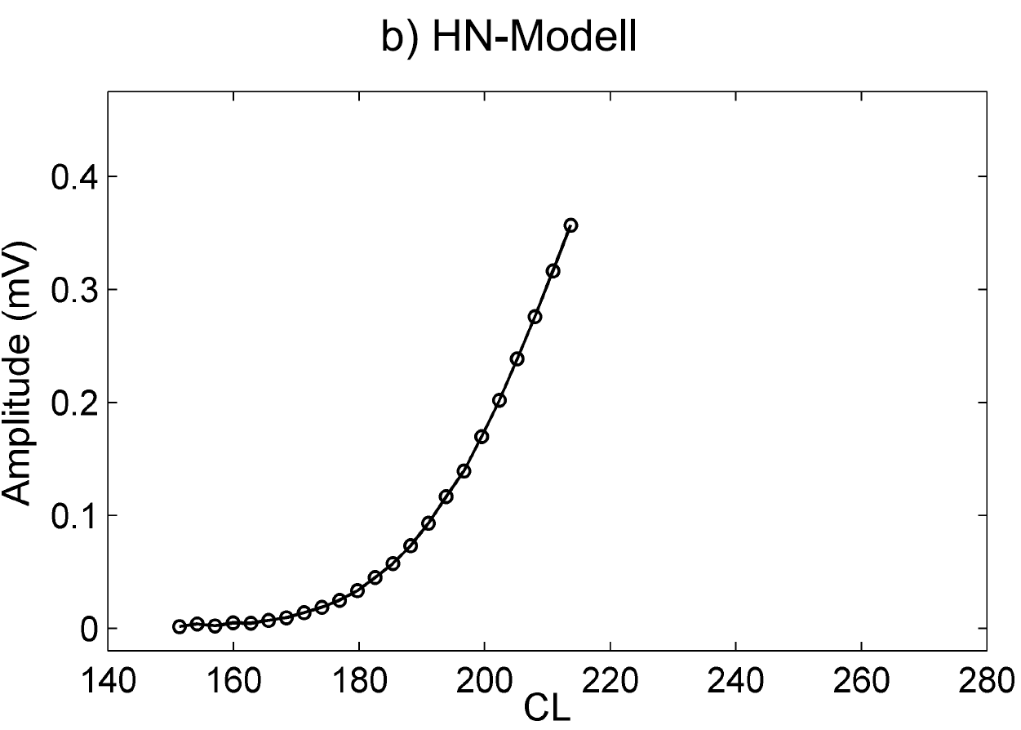
Figure 8: (from Hamacher 2004) Simulated ECAP growth function as measured by Abbas et al. 64 measurements were combined to obtain the smoothed graph.
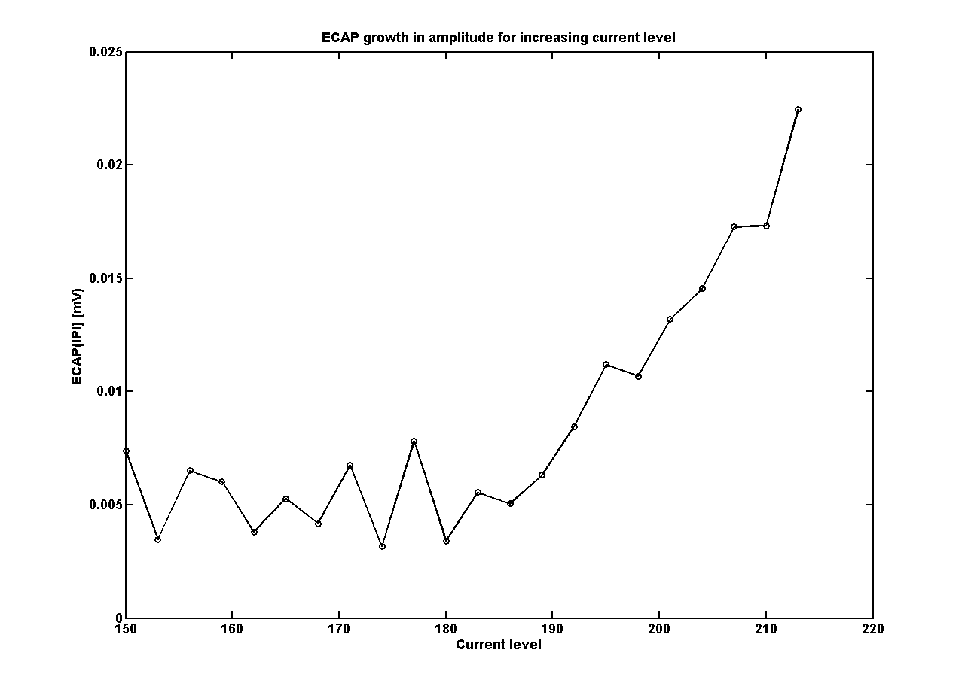
Figure 9: CINM-modelled ECAP growth function. The ECAP Amplitude increases when the current level is increased. This figure can be reproduced by clicking "Ecap growth" in the GUI.

ECAP regeneration functions
Figure 10 shows ECAP regeneration functions measured by Abbas et al. and simulated by Hamacher, 2004.The conditions of stimulation were the same as used for the ECAP growth functions. Regeneration functions are determined by the characteristics of the refractory of the activated auditory nerve cell and thus give important indications about the ability of the auditory nerve to transfer temporal information to subsequent stages of the auditory system. The regeneration function (using the subtraction method) is shown in form of the ECAP amplitude as a function of the temporal distance between masking and test stimulus (IPI). The ECAP amplitude decreases with increasing IPI, because it is the difference of the isolated and the masker-influenced test-stimulus-triggered neural potential. 0 is reached when the distance between test and masker is that high that the neural output of the reaction on the isolated test stimulus is the same as the reaction of the masker-influenced test stimulus. Figure 9 shows the model simulations, which both quantitatively and qualitatively agree well with the data. The model simulations also show that an increase in level leads to a faster recovery of the auditory nerve. This effect has its origin in the fact that an increase in level does not affect the refractory behavior. Thus, a stronger test stimulus can activate more auditory nerve cells, which are in the relative refractory period.
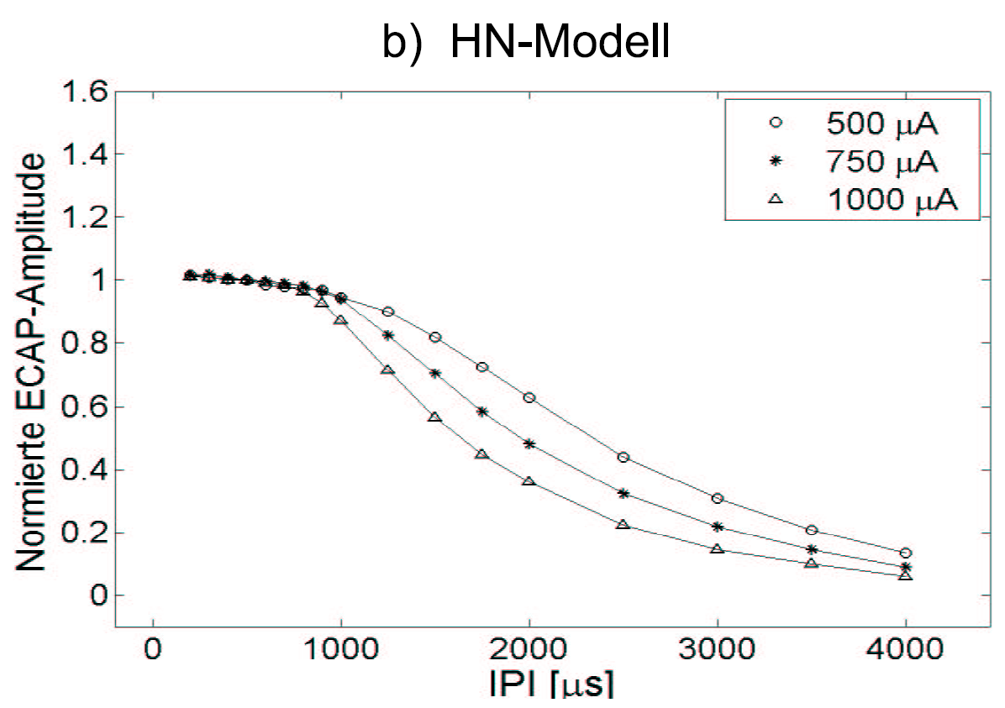
Figure 10 (from Hamacher 2004): Modelled ECAP Recovery functions calculated using the subtraction method for different inter-pulse-intervals. These graphs were obtained by plotting the average of 50-250 single graphs.
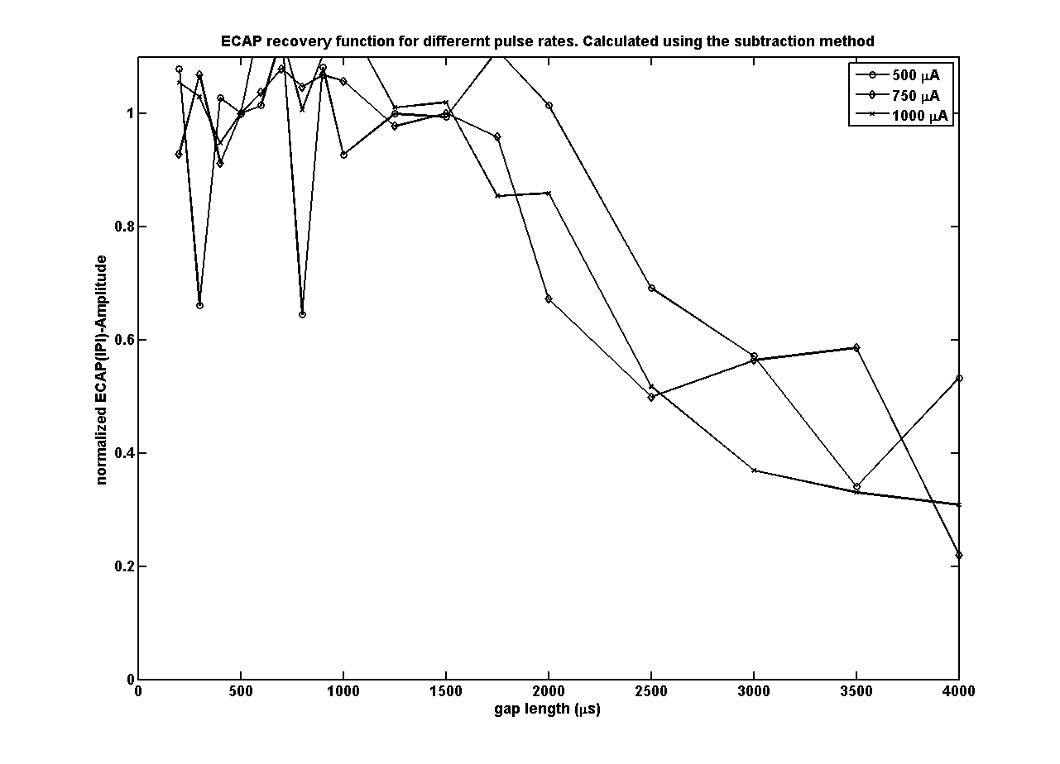
Figure 11: ECAP recovery function for different pulse rates. The recovery functions are calculated using the subtraction method. This figure can be reproduced by clicking the button “Recovery” in the ECAP-Panel of the CINM-GUI.

ECAP with stimulus sequences of constant amplitude
Electrical stimulus sequences shed light on long-term effects of temporally complex stimuli and thus are of high relevancy for understanding the response of the auditory nerve, e.g., to speech. Figure 10 shows (representative) ECAP amplitudes for stimulus sequences with different pulse rates measured by Wilson et al., in one CI listener. Pulse amplitudes were held constant and chosen in a way that the stimulus sequence was perceived as medium loud at 1016 Hz. For a better overview, the ECAP amplitudes (difference between maximum and minimum) were normalized according to the ECAP amplitudes of the first stimulus. It can be stated that up to a pulse rate of 200 Hz, the constant stimulus amplitudes are reflected in constant ECAP amplitudes. From 400 Hz onwards, an alternating time course of the ECAP amplitudes can be observed with relatively high amplitudes at odd stimulus indices and relatively low amplitudes at even stimulus indices. The cause of this alternating behavior can be found in the membrane stochastic and the refractory characteristics of the auditory nerve. At the first stimulus, all AN cells are in resting state, which means that the number of cells that are activated by the first stimulus is maximal. At the time of the second stimulus, those just activated AN cells are in their refractory time. Thus, less cells can react on that stimulus. At the third stimulus, the threshold of the AN cells, which were reacting on the first stimulus (but not on the second one) has almost returned to normal values, which in turn means a higher ECAP amplitude. A comparison of Figure 10 with the modeled ECAP amplitudes in Figure 11 shows a good agreement. All crucial characteristics of the measured data are met by the modeled data.
Figure 12 (from Hamacher 2004): Normalized ECAP-Amplitudes for stimulus sequences of different pulse rates.
Figure 13: Modeled normalized ECAP amplitudes for constant stimuli with different pulse rates. This figure can be reproduced by clicking the button “Sequenz Const” in the CINM-GUI

Amplitude modulated stimulus sequences
This section shows predictions of CINM at sinusoidally amplitude modulated stimulus sequences alongside corresponding measurements with CI listeners. The sinusoidal modulation of the stimulus amplitudes is done by weighting a stimulus sequence of constant amplitude I₀ by a modulation function w(i).
$$I\left(i\right)=I_{0}w\left(i\right), mit w\left(i\right)= \frac{1}{1+m_{s}}(1-m_{s}\cos\left(2π\frac{f_{mod}}{PR}i\right))$$
f_{mod} is here the modulation frequency and m_{s} is the modulation degree, whose values are between 0 and 1.
Figure 12 shows the influence of the modulation degree on the neural sum activity. In detail, the modeled ECAP amplitudes for the modulation frequencies of 101.6 Hz and 406.4 Hz are shown. The modulation degree was varied (0 0.11 0.33 0.67 and 1). Additionally, the normalized amplitudes of the respective stimuli are shown (which corresponds to the modulation function w(i)). Both modulation frequencies lead to a significant modulation of the neural signal amplitude. Even a relatively low modulation degree of 0.11 is already sufficient to result in a pronounced ECAP amplitude modulation.
Furthermore shown in Figure 13 are the ECAP amplitudes measured with one Ineraid system. There is a very good agreement between model and measurement result.
Figure 14 (from Hamacher 2004): Normalized ECAP amplitudes for SAM modulated stimuli with different modulation-frequencies and modulation.
Figure 15: Modeled normalized ECAP amplitudes for modulated stimuli with different modulations frequencies and modulation degrees. This figure can be reproduced by clicking the button "Sequenz mod" in the CINM-GUI

Speech intelligibility modeling
The prediction of speech intelligibility scores is based on a classiﬁcation of the internal representations of the single words from the Oldenburg sentences (OLSA, Wagener et al., 1999). The single words of the Oldenburg sentence test were added to olnoise (stationary noise with speech-shaped long-term spectrum) with SNRs ranging from 10 to 25 dB in 5 dB steps, while the noise level was ﬁxed at 65 dB. The signals were processed with the model, resulting in internal representations. This procedure was repeated ten times for each word and each SNR, with different passages of olnoise for each repetition. With 50 words from the Oldenburg sentence test and 10 repetitions, 500 internal representations were calculated for each SNR.
In the example in the GUI, only one single SNR and one configuration of the CI model is chosen for processing the internal representations: 0 dB SNR and 500 nerve cells. There are three buttons for this task, one to calculate stimulation patterns from the waveforms, one to calculate internal representations from the stimulation patterns, and one to do the pattern recognition using the DTW. Note that only pressing the buttons in the right succession will produce the desired output. All the data will be stored in the folder “results/Olsa”, which is a subfolder of “CImodelresults”.
Pressing the button [1. Generate electric signals] generates stimulation patterns from the waveforms. This button calls the script “main_generate_electric_signals_isaar.m”. These electrical stimulation patterns will be stored in the subfolder “ACE”.
Pressing the button [2. Generate template] generates internal representations from the stimulation patterns generated before. This step (depending on the power of your computation system) might take a while. Changing the chosen SNR and configuration of the model can be done within the function “main_CI_AN_model_isaar.m”. Of course, this only works if the stimulation patterns for the respective SNR have been chosen generated using the former script. In this example only two internal representations per word (one for training and one for testing) are generated. This data is here (default) stored in the “v3” subfolder.
The model approach chosen here is based on work of Jürgens and Brand (2009): It was assumed for the prediction that subjects performing the Oldenburg sentences test had a priori knowledge of the speech material due to their familiarization with the speech test. Hence, they had access to all words stored as internal representations as references. It was further assumed that subjects compared a presented test word to the stored list of references of the same word type and selected the reference that was closest to the test word. This was simulated as follows: A word that was presented with a speciﬁc SNR during the speech intelligibility test was represented by its internal representation IRtest. IRtest was compared to the stored internal representations of the alternative words of the same word type at the same SNR (reference representations IRref). The IRref that was most similar to IRtest represented the recognized word. The similarity of representations was calculated with a DTW as a speech classiﬁer. The DTW algorithm calculates the distance (cumulated sum of local Euclidean distances along an optimally time-warped path, that matches the patterns as well as possible) between the IRtest and each of the references IRref. For each of the ten words of one word type, represented by IRtest, the distances between IRtest and ten references IRref of the same word type were calculated. When the smallest distance was found, the test word was recognized as correct.
This recognition step is done by pressing the button [3. Perform classification] in the GUI. This calls the function “main_DTW_OLSA_isaar.m”, which adds the multiplicative noise (vector_my_std, default 0.30) to the internal representations and uses the dynamic time warping algorithm to compare the training and testing internal representations. In the end, the recognition rate averaged over all testing items is displayed on the command line.
The buttons of the speech intelligibility subpanel will thus calculate the red highlighted point in the intelligibility function of Figure 16 with only 1 repetition (instead of 9, which was used in the publication of Fredelake and Hohmann). The data will be stored in the subfolder “DTW” of the v3-directory.

Figure 16 (from Fredelake and Hohmann, 2012): Modeled speech intelligibility functions for different model conﬁgurations of the standard population model. The speech intelligibility is plotted against the SNR. The legend denotes the different model conﬁgurations. The speech intelligibility is plotted against the SNR. The legend denotes the different model conﬁgurations. The number of auditory nerve cells decreases from version v1 to v6. The standard deviation of the internal noise was σ_{int} = 0.30. The blue highlighted dot is calculated using the two buttons of the GUI.

Parameters
All Parameters are stored in m-files in the subdirectory parameterstore. set_global_constants.m is the most recent version.

Units
All Parameters are in SI-Units.

Current Restrictions
There is no binaural input. The number of electrodes in the cochlea implant simulation is fixed at 22 Electrodes. Only ACE Processing strategy is used.

Literature
Busby, P.A., Whitford, L.A., Blamey, P.A., Richardson, L.M., Clark, G.M., 1994. “Pitch perception for different modes of stimulation using the cochlear multipleelectrode prosthesis.” J. Acoust. Soc. Am. 95, 2658-2669
Fredelake, S., and Hohmann, V. (2012). “Factors affecting predicted speech intelligibility with cochlear implants in an auditory model for electrical stimulation,” Hearing Research, 287, 76–90. doi:10.1016/j.heares.2012.03.005

Fredelake, S., and Hohmann, V. (2012). “Factors affecting predicted speech intelligibility with cochlear implants in an auditory model for electrical stimulation – Supplementary material

Gerstner, W., Kistler, W.M., 2002. Spiking Neuron Models - Single Neurons, Populations, Plasticity. Cambridge University Press.
Hamacher, V. (2004). Signalverarbeitungsmodelle des elektrisch stimulierten Gehörs Ph.D.-Thesis, Rheinisch-Westfälischen Technischen Hochschule Aachen, Wissenschaftsverlag Mainz in Aachen, 1.Edition

Jürgens, T. and T. Brand (2009). "Microscopic prediction of speech recognition for listeners with normal hearing in noise using an auditory model." J. Acoust. Soc. Am. 126(5): 2635-2648.

Vandali, A. E., Whitford, L. A., Plant, K. L., and Clark, G. M. (2000). “Speech perception as a function of electrical stimulation rate: using the Nucleus 24 cochlear implant system,” Ear and hearing, 21, 608–624.
Wagener, K., T. Brand, et al. (1999). "Entwicklung und Evaluation eines Satztests für die deutsche Sprache I: Design des Oldenburger Satztests." Zeitschrift für Audiologie/Audiological Acoustics 38(1): 4-15.

